USING “PROENV” to manually disconnect a user from the database. 2/14/07

There may very occasionally be a need to do a manual shut-down of a single user. This can occur if a user is connected to the Progress database and then unplugs their PC, turns off their PC, or looses their network connection (either cabled or RF) while they are still logged into the ASI application and database.

Step 1:
Determine which device needs to be disconnected manually via Proshut.
If a device losses connectivity to the server (as described above) another user will typically get an error message when they are trying to access or post data that is being “held” by the disconnected user. The error message may be something like:

“Item / Record in use by USER ID PC 1 on PC 999999999999, wait or push cancel to stop”. Where the “USER ID PC 1” is the user name assigned to the locked PC and the “999999999999” is the “tty” name of the device.
In our sample below the exact message was:
“Item FG in use by Forklift, 24 on PC 162522230926 wait or push cancel to stop”

Step 2:
You will need to know what drive the ASI database resides on. It is typically on the C or D drive of your server – but, if you do not know do a right mouse click on the start button and go to explore to see where the ASI database is at.

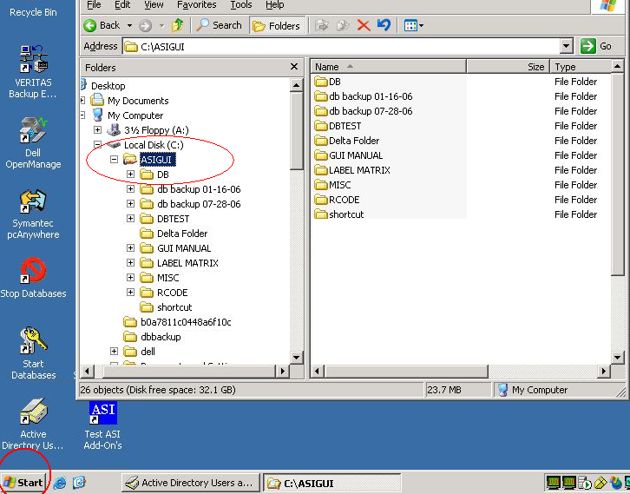

Step 3:
From the server go to Programs, Progress and select “Proenv”.

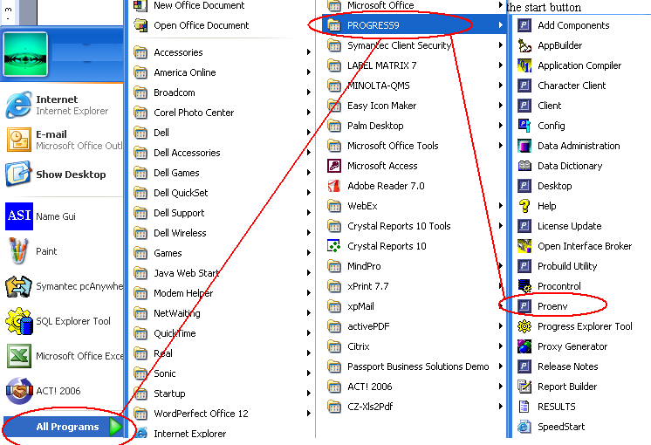

Step 4:
Proenv will launch a DOS shell looking screen. Type d:/asigui/db/asi <hit enter>
Note: If your database is on another drive substitute that drive letter for the d:

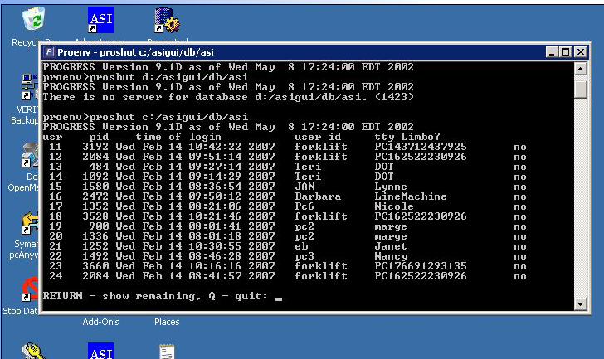

If you have more than 14 connected devices you can hit RETURN (enter) to get to the bottom of the list.

Step 5:
At the bottom of the list you will see a menu with the option to disconnect a user. Select option #1 and enter the user number of the device that needs to be shut down.
You can then exit this screen.

